Bradford has created a new Children and Families Trust, which has been commissioned by Bradford Council to deliver a wide range of services for children, families and young people on their behalf. The Trust is accountable for determining how outcomes of these services are achieved and for the day-to-day running of commissioned children’s services.

This is an important opportunity to renew our approach to delivering the support that Bradford’s children, young people and families in need, by renewing services and creating a new organisation. We are bringing the mindset, dynamism and energy of a start-up together with the national expertise and determination of the Trust’s Board, senior leadership and our colleagues’ practical experiences of providing children’s services in Bradford.

As a new organisation, Bradford Children and Families Trust has established our own purpose, vision, and outcomes for what we aim to achieve.

Our vision: For all children and young people in Bradford to be safe and able to realise their full potential.

Our purpose: To provide high-quality services with partners that help safeguard, support and promote the welfare of children, young people and families across the Bradford District.

We will achieve this through continuous improvements in our services and positive collaboration with our staff, our partner organisations.

Role Title: Business Support Officer
Salary: Grade Band 6
Location: Bradford, Sir Henry Mitchell House
Report to: Quality Assurance and Practice Improvement Team Manager
Sap Position Number: 50216553

About Us

Learning and Quality Assurance Service Overview

The role sits within the Learning and Quality Assurance service which is comprised as set out below.
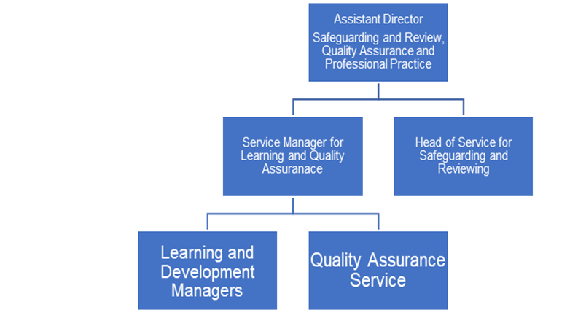

Role Summary

The role requires the individual to support to the Quality Assurance and Practice Improvement Team in its function within the Bradford Children and Families Trust, to improve practice directly leading to positive outcomes for children, young people and families. The role is key in the data quality and improvement activities of Bradford Child and Families Trust.
The role will require the individual to be responsible for the collation of audit data to present to the Team Manager to use within their report writing.
The role will also require the individual to provide data in response to requests from internal and external in relation to quality assurance activity.
The individual will have an understanding and knowledge of inspection preparation and activities, performance management and quality assurance.

Main Duties and Responsibilities

- To play a key role in critical aspects of the Bradford Children and Families Trust quality assurance cycle.
- To pull data and information from PowerBi and other data sources, to support the Team Manager in writing monthly reports for Senior Leadership.
- Be able to present data sets through Excel/Word when needed.
- To support the quality assurance team and senior leadership team in preparation for Ofsted inspections by gathering and collating data.
- Generate the monthly audit samples for BCFT, to be disseminated by the team manager, and update the database regular to ensure exemptions are up to date.
- To support improvement activities in the provision of data and information from audit findings to support the Team Manager writing and presenting strengths and leanring in practice to Senior Leadership within BCFT and partners insight to inform effective policy development implementation and efficient service design, change and delivery.
- To provide a business support function to the quality assurance team.
- Maintain high levels of confidentiality and be sensitive to the personal nature of data handled within the Quality Assurance and Improvement Team.
- Work within all relevant policies, procedures and systems established corporately or locally and support the Trust’s Equal Opportunities Policies.
- Carry out duties in accordance with the Trust Values and Culture.
- Undertake any duties commensurate with the post that may be allocated from time to time as agreed with your line manager.
- Demonstrate a personal commitment to continuous self-development and service improvement.

About you

Knowledge and Experience
Demonstrate knowledge and understanding of the duties and responsibilities that underpin the work of functions within Children’s Services and knowledge of one or more particular area of Children’s Services work including that which is: practice facing; inspection preparation, practice improvement, performance management, quality assurance, change management or project management.
Knows when to investigate outputs further and offers explanations. Validates the quality of the data and analyses against external sources and research. Resolves issues using the appropriate methods. Feeds back results of validation to those responsible for the data and information.
Ability to adopt a process of continual improvement and suggest ways of working more efficient and effectively to improve service delivery.
Carries out the working practices, procedures and basic operations across Children’s Services.
Able to work effectively with a wide range of colleagues (and other stakeholders) across the Trust and in partner organisations in relation to project activities, including planning, performance management, research, consultation, finance, HR, Legal etc.
Able to work flexibly at pace, prioritise, and deal with a demanding workload to meet objectives and timescales and be adaptable to changing circumstances and priorities.
Uses a range of specialist ICT systems across own work area and or across other areas of work.
Uses, interprets, analyses and communicates complex information from a variety of sources.
Qualifications
The applicant is required to provide evidence of having previously spoken fluently in English to meet either the Lower threshold or Advanced threshold level outlined under Special Knowledge above.
Experience working within a large multi-functional public sector or similar organisation conducting the role of a business support/ data analytics.
Experience of using both MS Office products, Power Bi, Word, Excel and other IT Systems.
GCSE Maths and English at Grades A-C or be able to demonstrate good literacy and numeracy through assessment before interview.
Level 4 NVQ is desirable but not essential.

Safeguarding

Bradford Children and Families Trust is committed to safeguarding and promoting the welfare of all children who use our services and as such expects all staff to share this commitment. Successful applicants will be required to complete the relevant safeguarding checks. An DBS check will be requested. We are an equal opportunities employer

